PROBLEM STATEMENT:

Adjust contrast in an Image using Histogram Equalization. A from-scratch implementation with neat documentation is expected with code, Explanation, Input, and Output Image.

EXPLANATION:

Histogram equalization is a method in image processing of contrast adjustment using the image's histogram. This method usually increases the global contrast of many images, especially when the usable data of the image is represented by close contrast values.

REQUIREMENTS:

OpenCV inbuilt function

CODE:

#include <opencv2/opencv.hpp>

#include <iostream>

using namespace cv;

using namespace std;

int main(int argc, char** argv)

{

// Read the image file

Mat image = imread("C:\Users\rosini\Downloads");

// Check for failure

if (image.empty())

{

cout << "Could not open or find the image" << endl;

cin.get(); //wait for any key press

return -1;

}

//change the color image to grayscale image

cvtColor(image, image, COLOR_BGR2GRAY);

//equalize the histogram

Mat hist_equalized_image;

equalizeHist(image, hist_equalized_image);

//Define names of windows

String windowNameOfOriginalImage = "Original Image";

String windowNameOfHistogramEqualized = "Histogram Equalized Image";

// Create windows with the above names

namedWindow(windowNameOfOriginalImage, WINDOW_NORMAL);

namedWindow(windowNameOfHistogramEqualized, WINDOW_NORMAL);

// Show images inside created windows.

imshow(windowNameOfOriginalImage, image);

imshow(windowNameOfHistogramEqualized, hist_equalized_image);

waitKey(0); // Wait for any keystroke in one of the windows

destroyAllWindows(); //Destroy all open windows

return 0;

}

INPUT IMAGE:

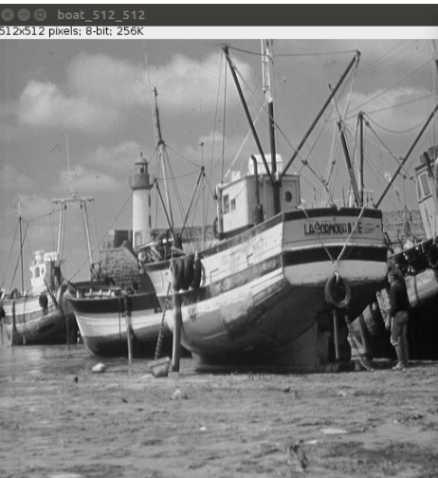

OUTPUT:

